ECEN 454 - Lab Report

Lab Number: 9
Lab Title: Optimization using Logical Effort
Section Number: 341
Student’s Name: Abhishek Bhattacharyya
Student’s UIN: 731002289
Date: 11/17/2024

TA: Nishank Bansal

Circuit Schematic w/ Critical Path Highlighted
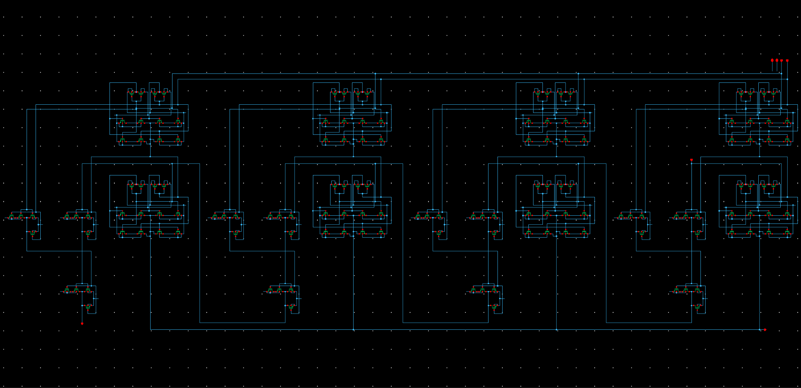
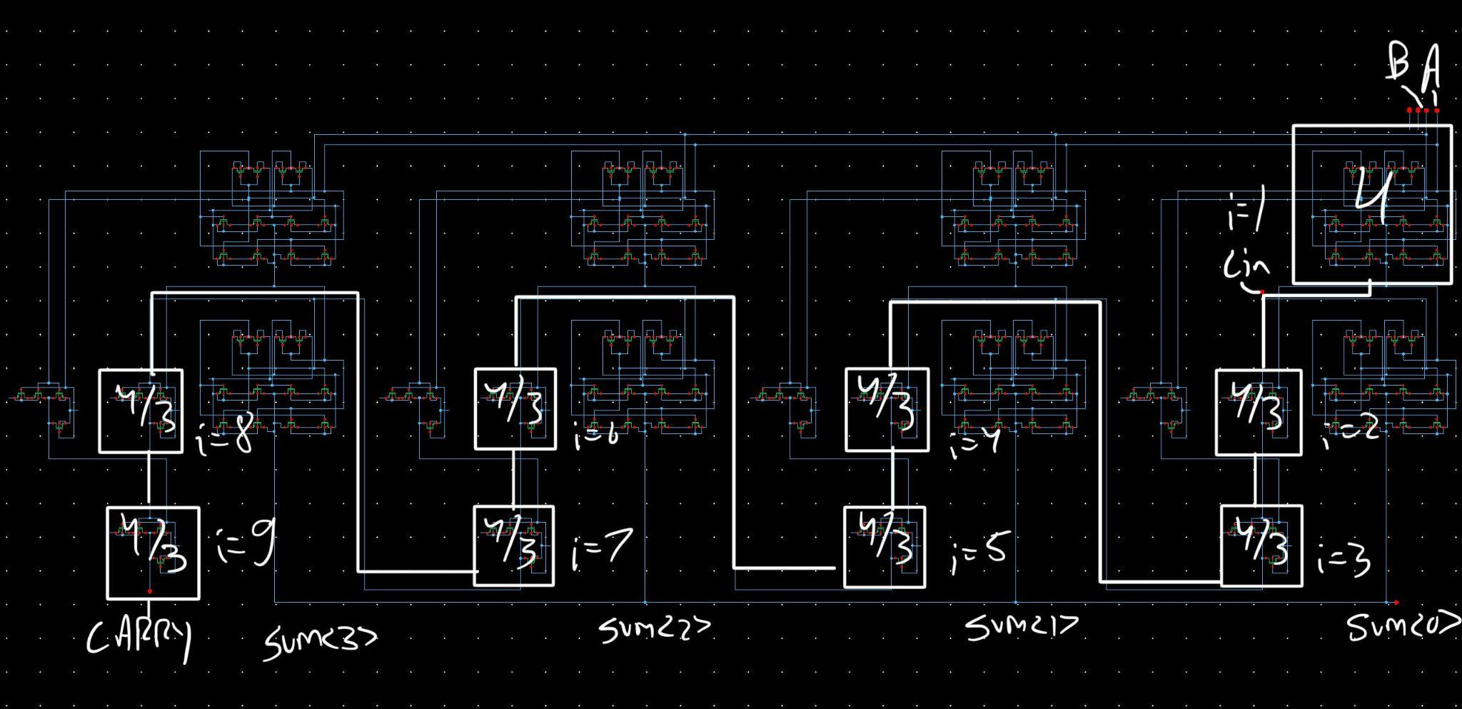

Logical Effort Calculations (G, B, H) & Procedure

Explanation of Procedure
I used Google Sheets for all logical effort calculations, following the procedure as laid out in the lab manual and the provided Sutherland_Ch1.pdf. I have shared this google sheet at this link in case there are any questions about my calculations. My procedure and formulas were:
I first looked up the values of sink capacitances from Lab 3. This gave me:
C_{NAND} = 2.23fF
C_{XOR} = 7.51 fF
I then calculated the Path Logical Effort (G) by taking the product of each of the gate’s g:
G = 4 * (4/3)⁸ = 39.955
I then calculated Path Electrical Effort (H) as C_{load} / C_{XOR}:
H = C_{load} / C_{XOR} = 30 fF / 7.51fF = 3.995
Finally, I calculated Path Branching Effort (B) as the product of b₀ * b₁ * … * b₉. I calculated b_{i} for each device using the formulas given in the lab manual:
b₁ = (C_{XOR} + C_{NAND})/C_{XOR} = 1.30
b_{3, 5, 7, 9} = 1
b_{2, 4, 6, 8} = (C_{XOR} + C_{NAND})/C_{NAND} = 4.37
B = b₁ * b₂ * … * b₉ = 1.30 * 1 * (4.37)⁴ = 471.99
Finally, I calculated Path Effort (F) as F = G*B*H, and Stage Effort (f̂) as f̂ =F^{1/9}

Final Values
Cnand | 2.23E-15
Cxor | 7.51E-15
Gxor | 4
Gnand | 1.333333333
G | 39.95488493
H | 3.99
B | 471.9928233
F | 75333.23146
f̂ | 3.482470127

Resizing Procedure & Final Transistor Sizes
Using the procedure above, I found a value of f̂ = 3.482. Since If 2.7 < f̂ < 4, I performed the following resizing:
- For the i-th gate (i = 9, 8, … , 1), calculate C_{in,i} = g_{i}C_{out,i}/ f̂
- If C_{in, i} < C_{gate} keep the size. Otherwise, resize the width of W_{n} and W_{p} by ratio C_{in, i} / C_{gate}
To do this, I first calculated C_{in, i} for each gate starting from i = 9 (final NAND gate, as labeled in my critical path schematic) and ending at i = 1 (first XOR gate). The gates at i =7, 5, 3, and 1 are highlighted as they have an additional capacitance for the XOR gate that needs to be added. This is reflected in the formulas given below:
Gate (i) | Formula | Cin | Resize by (if green)
9 (NAND) | C_{in, 9} =(4/3 * C_{load}) /f̂ | 1.15E-14 | 5.150717473
8 (NAND) | C_{in, 8} =(4/3 * C_{in, 9}) /f̂ | 4.40E-15 | 1.972055193
7 (NAND) | C_{in, 7} =[4/3 * (C_{in, 8}+C_{XOR})] /f̂ | 4.56E-15 | 2.044437043
6 (NAND) | C_{in, 6} =(4/3 * C_{in, 7}) /f̂ | 1.75E-15 | 0.7827536083
5 (NAND) | C_{in, 5} =[4/3 * (C_{in, 6}+C_{XOR})] /f̂ | 3.54E-15 | 1.589089147
4 (NAND) | C_{in, 4} =(4/3 * C_{in, 5}) /f̂ | 1.36E-15 | 0.6084145598
3 (NAND) | C_{in, 3} =[4/3 * (C_{in, 4}+C_{XOR})] /f̂ | 3.39E-15 | 1.522339956
2 (NAND) | C_{in, 2} =(4/3 * C_{in, 3}) /f̂ | 1.30E-15 | 0.5828582971
1 (XOR) | C_{in, 1} =[4 * (C_{in, 2}+C_{XOR})] /f̂ | 1.01E-14 | 1.347402728
I then calculated the resizing factor for each gate as C_{in, i} / C_{gate} in the “Resize by” column. If the value is less than one, then we get C_{in, i} < C_{gate} and keep the size. I used conditional formatting to highlight all gates with a value greater than one and only these were resized.
Below are the sizing used for unoptimized and optimized gates:

Unoptimized Gate Sizing:
Unoptimized
Inv | W_p | 1100n
 | W_n | 400n
NAND | W_p | 600n
 | W_n | 300n
XOR | W_p | 1600n
 | W_n | 400n

Optimized Gate Sizing:
Note: The gate numbers given here correspond to the gates on the critical path schematic (using the i variable). For the “optimized” sizing, these specific sizes were used for each gate on the critical path. For all gates NOT on the critical path, the sizing was left unchanged.
Optimized
NAND9 | W_p | 3090.430484
 | W_n | 1545.215242
NAND8 | W_p | 1183.233116
 | W_n | 591.6165578
NAND7 | W_p | 1226.662226
 | W_n | 613.331113
NAND6 | W_p | 600
 | W_n | 300
NAND5 | W_p | 953.4534882
 | W_n | 476.7267441
NAND4 | W_p | 600
 | W_n | 300
NAND3 | W_p | 913.4039735
 | W_n | 456.7019867
NAND2 | W_p | 600
 | W_n | 300
XOR1 | W_p | 2155.844364
 | W_n | 538.9610911
XOR1 (INV) | W_p | 1482.143001
 | W_n | 538.9610911

Simulation Waveforms

Case 1: A=0000, B=1111, Carry In=1

Unoptimized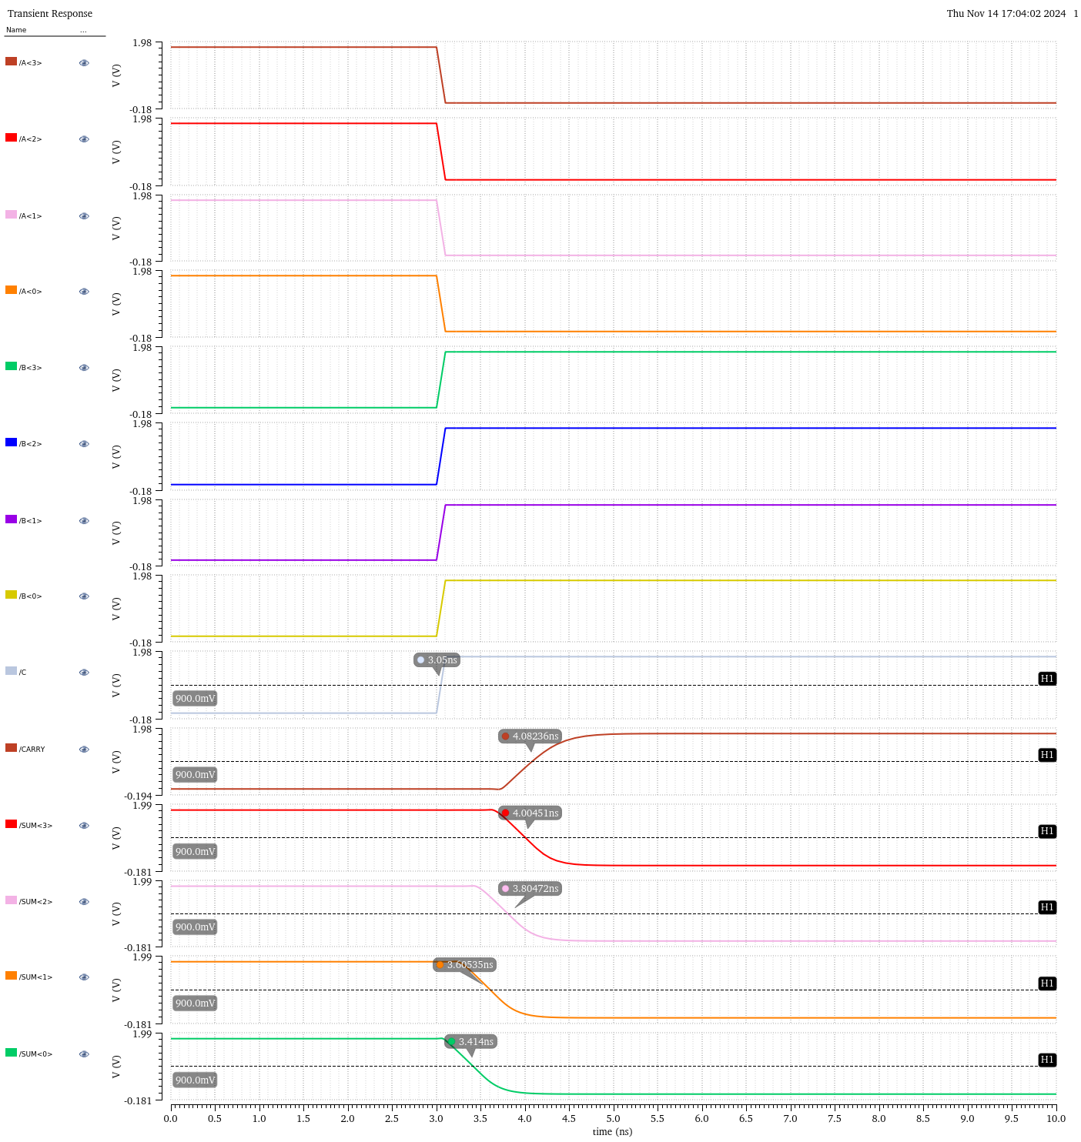

Optimized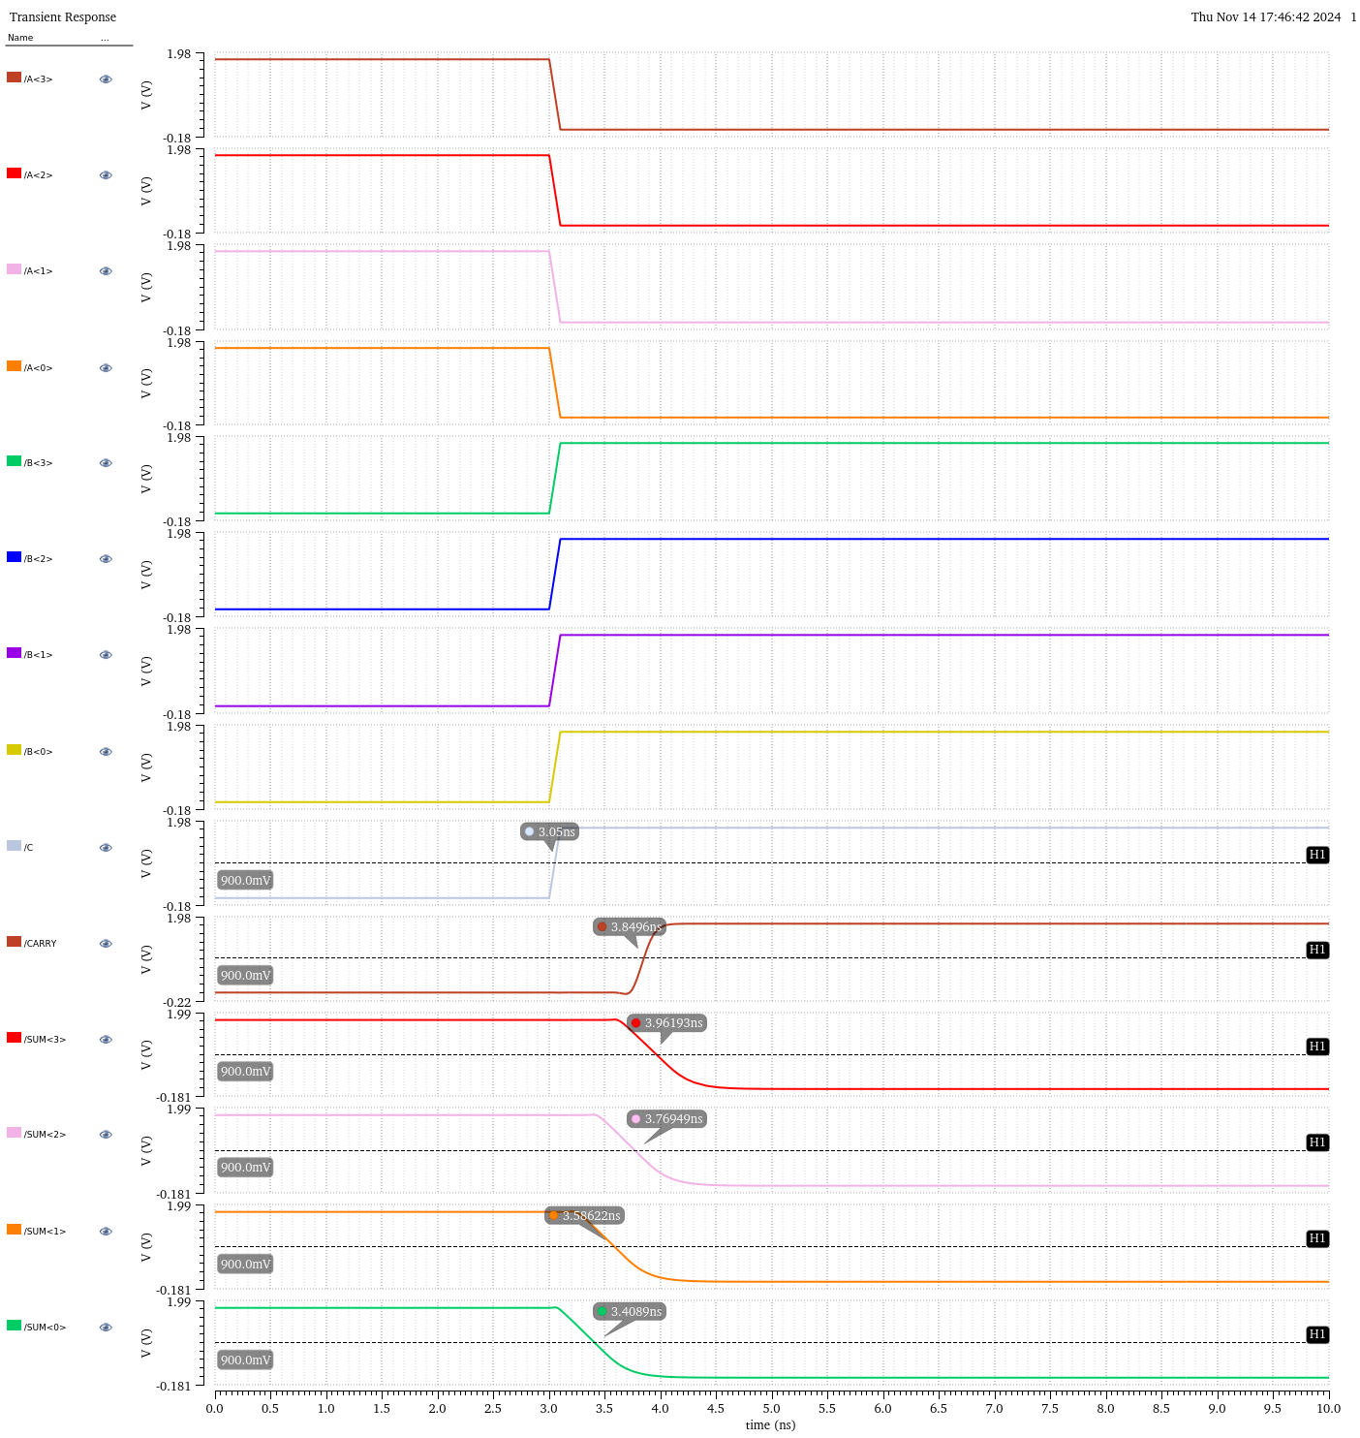

Case 2: A=1010, B=0101, Carry In=0

Unoptimized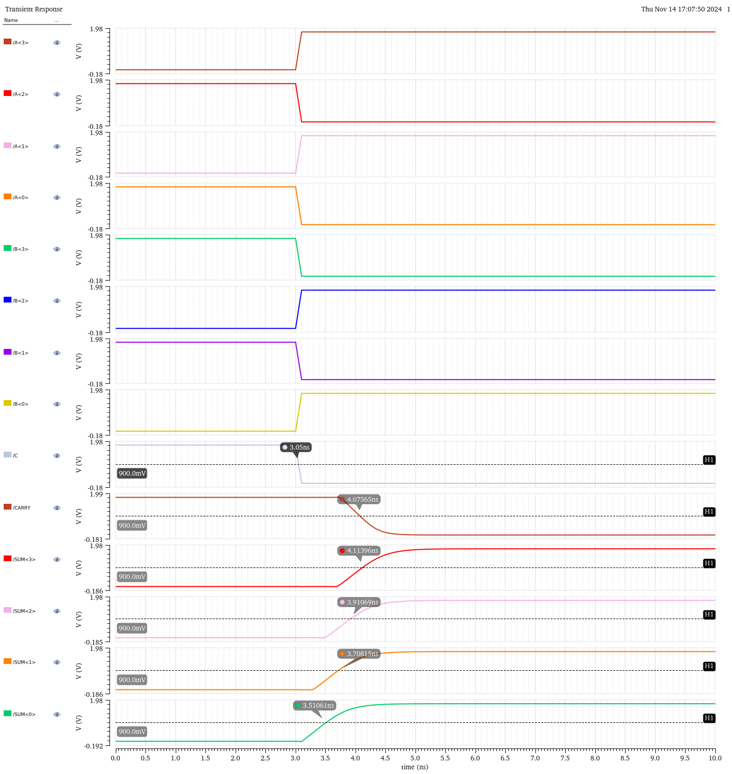

Optimized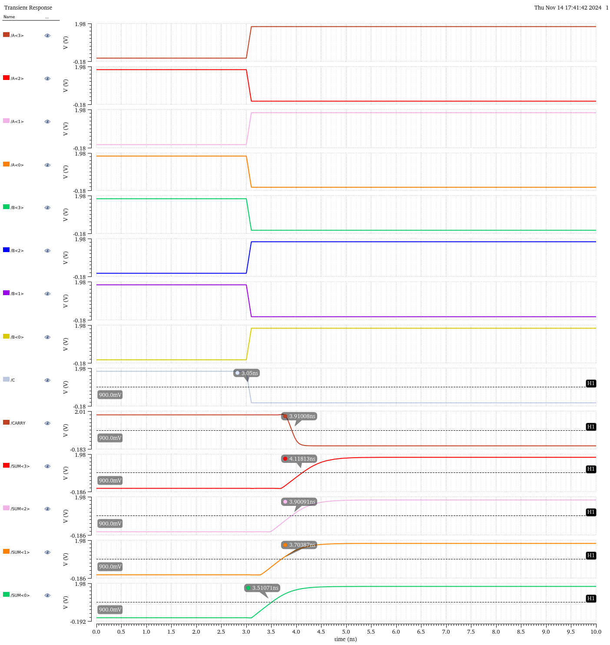

Case 3: A=1010, B=0101, Carry In=1

Unoptimized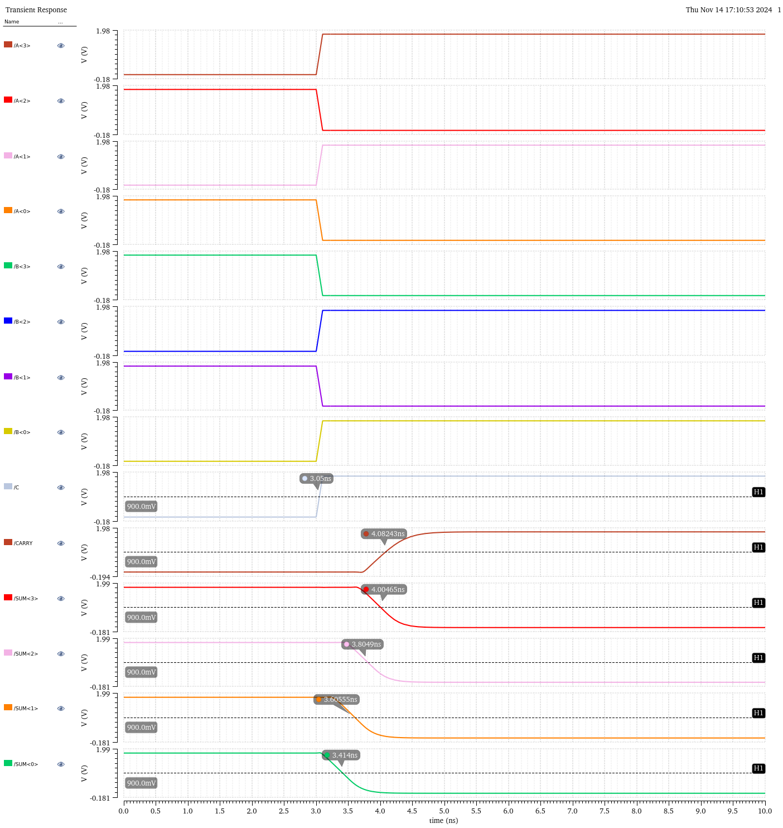

Optimized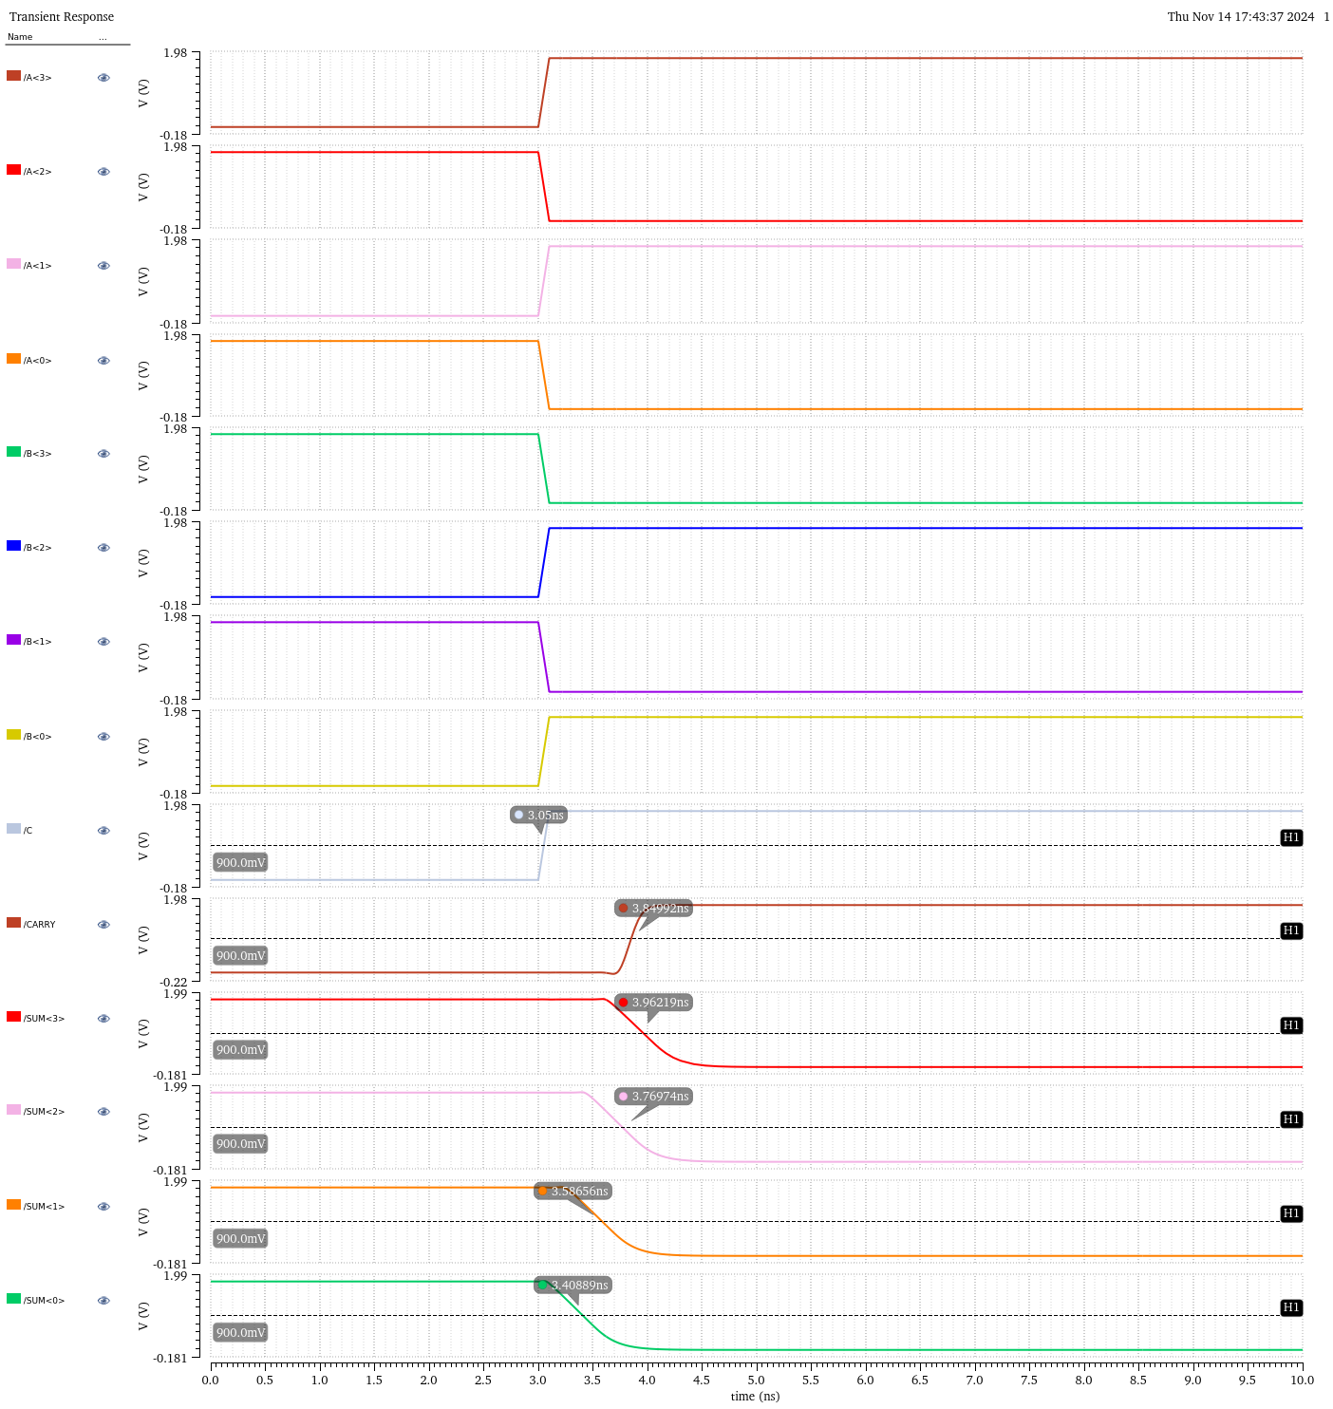

Case 4: A=1100, B=1000, Carry In=0

Unoptimized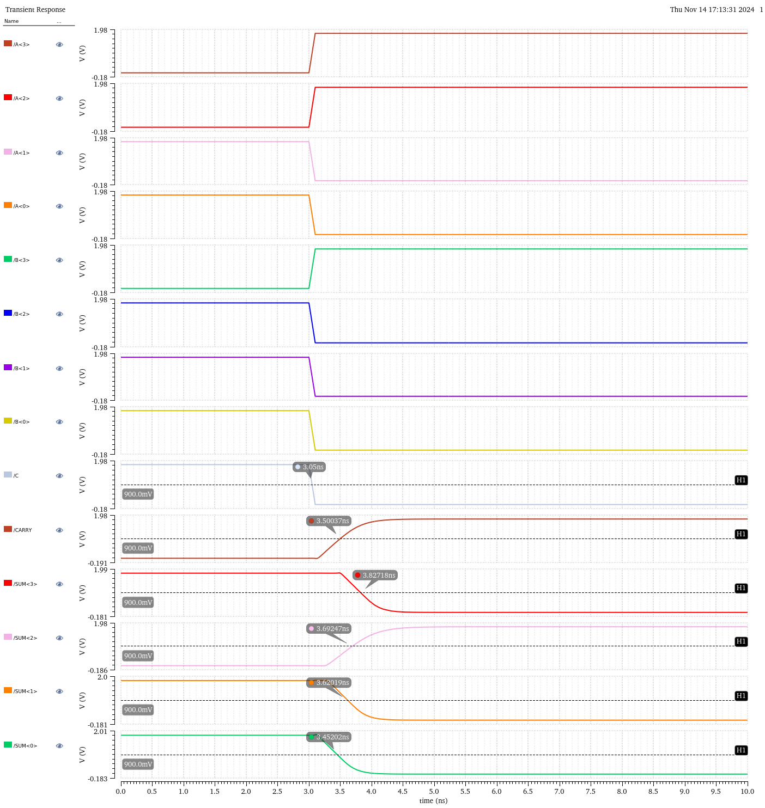

Optimized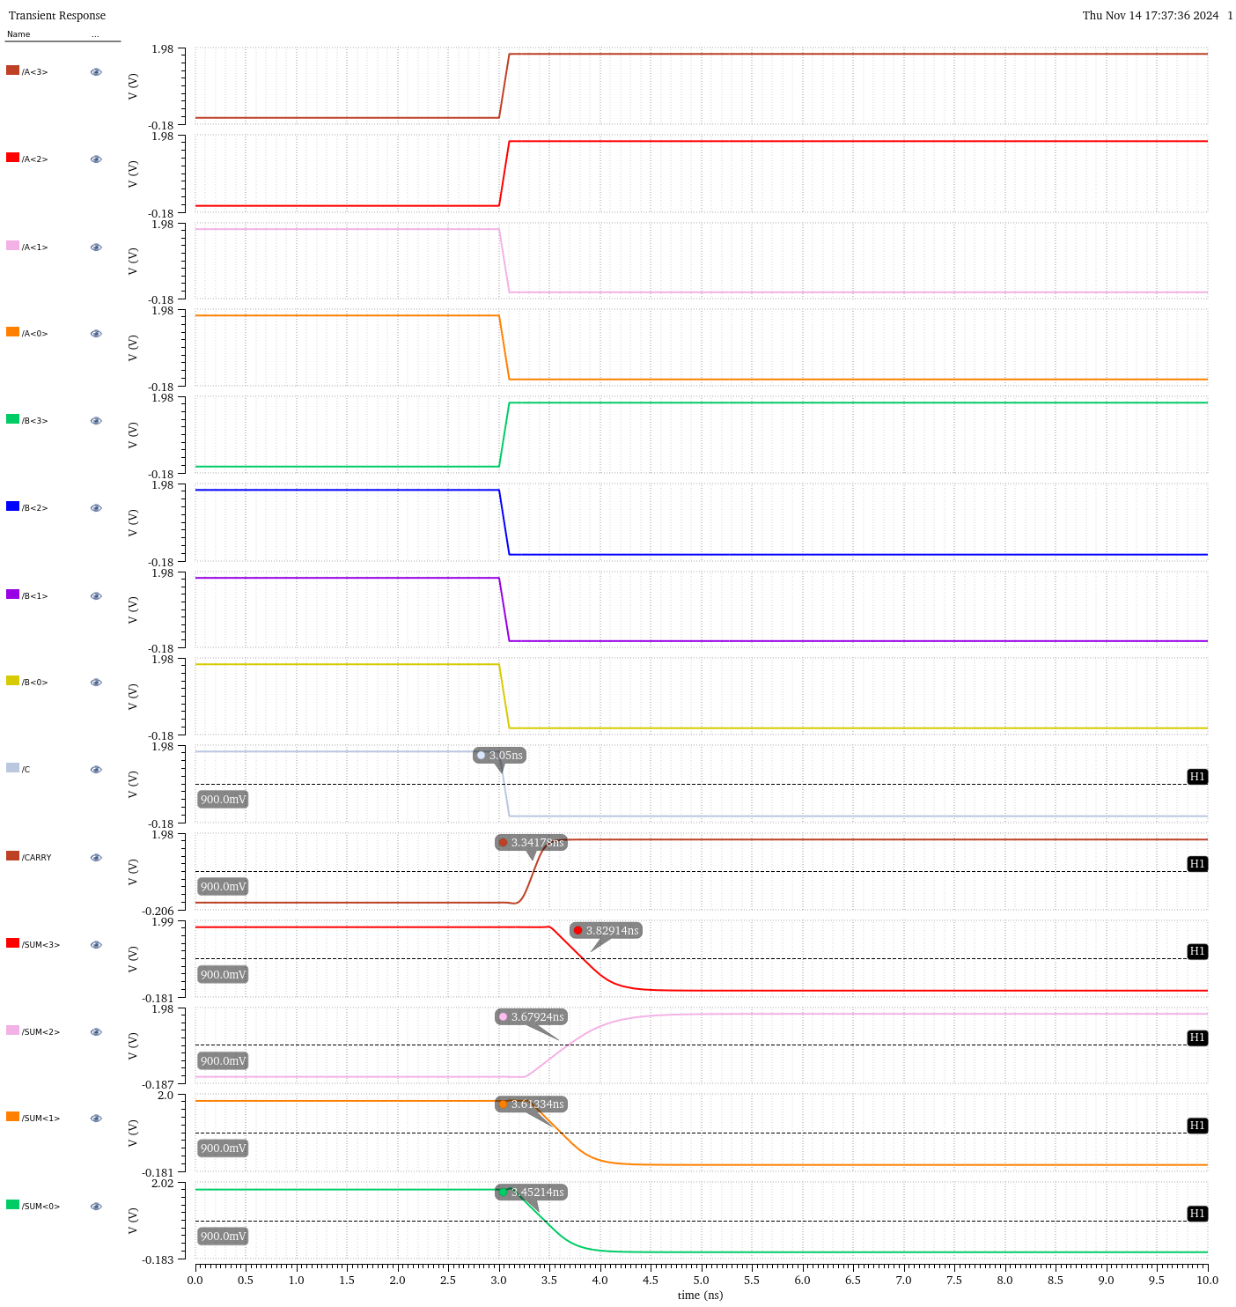

Delays, Unoptimized vs. Optimized
Note: I used conditional formatting here to color the cells and make any improvement in delay for the optimized design easier to spot. Delay is evaluated as Rise Time - 3.05, which was the measured time of the rising edge of the input signals (shown in the simulation waveforms).
 |  | Rise Time (ns) |  | Delay (ps)
Case | Pin | Non-Optimized | Optimized | Non-Optimized | Optimized
A=0000  B=1111  Carry In=1 | CARRY | 4.08236 | 3.8496 | 1032.36 | 799.6
 | SUM<3> | 4.00451 | 3.96193 | 954.51 | 911.93
 | SUM<2> | 3.80472 | 3.76949 | 754.72 | 719.49
 | SUM<1> | 3.60535 | 3.58622 | 555.35 | 536.22
 | SUM<0> | 3.414 | 3.4089 | 364 | 358.9
A=1010  B=0101  Carry In=0 | CARRY | 4.07565 | 3.91008 | 1025.65 | 860.08
 | SUM<3> | 4.11396 | 4.11813 | 1063.96 | 1068.13
 | SUM<2> | 3.91069 | 3.90091 | 860.69 | 850.91
 | SUM<1> | 3.70815 | 3.70387 | 658.15 | 653.87
 | SUM<0> | 3.51061 | 3.51071 | 460.61 | 460.71
A=1010  B=0101  Carry In=1 | CARRY | 4.08243 | 3.84992 | 1032.43 | 799.92
 | SUM<3> | 4.00465 | 3.96219 | 954.65 | 912.19
 | SUM<2> | 3.8049 | 3.76974 | 754.9 | 719.74
 | SUM<1> | 3.60555 | 3.58656 | 555.55 | 536.56
 | SUM<0> | 3.414 | 3.40889 | 364 | 358.89
A=1100  B=1000  Carry In=0 | CARRY | 3.50037 | 3.3417 | 450.37 | 291.7
 | SUM<3> | 3.82718 | 3.82914 | 777.18 | 779.14
 | SUM<2> | 3.69247 | 3.67924 | 642.47 | 629.24
 | SUM<1> | 3.62019 | 3.61334 | 570.19 | 563.34
 | SUM<0> | 3.45202 | 3.45214 | 402.02 | 402.14

Power Consumption, Unoptimized vs. Optimized
The optimized design consumed ~10 uW more power for all tests. This is expected, as the larger transistor sizing causes higher power consumption.
 | Power
Case | Non-Optimized | Optimized
A=0000  B=1111  Carry In=1 | 55.73 uW | 63.74 uW
A=1010  B=0101  Carry In=0 | 105.5 uW | 115.4 uW
A=1010  B=0101  Carry In=1 | 55.89 uW | 63.89 uW
A=1100  B=1000  Carry In=0 | 81.59 uW | 93.68 uW

Area, Unoptimized vs. Optimized
Here, the area is in units of picometers squared. Calculations are given in the Appendix below.
Area
Non-Optimized | Optimized
20.19 pm² | 71.6 pm²

Appendix: Area Calculations
I calculated the area by finding the area of each transistor type (XOR_{NMOS}, XOR_{PMOS}, etc.) and then multiplying this by the product of the number of transistors in each gate and the number of instances of each gate in the design. For the unoptimized design, I considered each of the critical path gates (i = 9, 8, …, 1) separately. I used the below table of formulas for the calculations.
Unoptimized
Gate | Transistor | Width | Length | # of Gates | # Transistors (each) | Area
Inv | W_p | 1.10E-06 | 2.00E-07 | 16 | 1 | 3.52E-12
 | W_n | 4.00E-07 | 2.00E-07 | 16 | 1 | 1.28E-12
NAND | W_p | 6.00E-07 | 2.00E-07 | 12 | 2 | 2.88E-12
 | W_n | 3.00E-07 | 2.00E-07 | 12 | 2 | 1.44E-12
XOR | W_p | 1.60E-06 | 2.00E-07 | 8 | 4 | 1.02E-11
 | W_n | 4.00E-07 | 2.00E-07 | 8 | 4 | 2.56E-12
 |  |  |  |  |  | 2.19E-11
Optimized
Gate | Transistor | Width | Length | # of Gates | # Transistors (each) | Area
Inv | W_p | 1.10E-06 | 2.00E-07 | 14 | 1 | 3.08E-12
 | W_n | 4.00E-07 | 2.00E-07 | 14 | 1 | 1.12E-12
NAND | W_p | 6.00E-07 | 2.00E-07 | 4 | 2 | 9.60E-13
 | W_n | 3.00E-07 | 2.00E-07 | 4 | 2 | 4.80E-13
XOR | W_p | 1.60E-06 | 2.00E-07 | 7 | 4 | 8.96E-12
 | W_n | 4.00E-07 | 2.00E-07 | 7 | 4 | 2.24E-12
NAND9 | W_p | 3.09E-06 | 2.00E-07 | 1 | 2 | 1.24E-12
 | W_n | 1.55E-06 | 2.00E-07 | 1 | 2 | 6.18E-13
NAND8 | W_p | 1.18E-06 | 2.00E-07 | 1 | 2 | 4.73E-13
 | W_n | 5.92E-07 | 2.00E-07 | 1 | 2 | 2.37E-13
NAND7 | W_p | 1.23E-06 | 2.00E-07 | 1 | 2 | 4.91E-13
 | W_n | 6.13E-07 | 2.00E-07 | 1 | 2 | 2.45E-13
NAND6 | W_p | 6.00E-07 | 2.00E-07 | 1 | 2 | 2.40E-13
 | W_n | 3.00E-07 | 2.00E-07 | 1 | 2 | 1.20E-13
NAND5 | W_p | 9.53E-07 | 2.00E-07 | 1 | 2 | 3.81E-13
 | W_n | 4.77E-07 | 2.00E-07 | 1 | 2 | 1.91E-13
NAND4 | W_p | 6.00E-07 | 2.00E-07 | 1 | 2 | 2.40E-13
 | W_n | 3.00E-07 | 2.00E-07 | 1 | 2 | 1.20E-13
NAND3 | W_p | 9.13E-07 | 2.00E-07 | 1 | 2 | 3.65E-13
 | W_n | 4.57E-07 | 2.00E-07 | 1 | 2 | 1.83E-13
NAND2 | W_p | 6.00E-07 | 2.00E-07 | 1 | 2 | 2.40E-13
 | W_n | 3.00E-07 | 2.00E-07 | 1 | 2 | 1.20E-13
XOR1 | W_p | 2.16E-06 | 2.00E-07 | 1 | 4 | 1.72E-12
 | W_n | 5.39E-07 | 2.00E-07 | 1 | 4 | 4.31E-13
XOR1 (INV) | W_p | 1.48E-06 | 2.00E-07 | 2 | 4 | 2.37E-12
 | W_n | 5.39E-07 | 2.00E-07 | 2 | 4 | 8.62E-13
 |  |  |  |  |  | 7.16E-11

